AI Surrogate Thermal Wind Tunnel

Introduction
The ‘AI Surrogate Thermal Wind Tunnel’ is a simulator for the flow of fluid over arbitrary 2D shapes. Instead of the usage of the Navier-Stokes equations to predict motion of the fluid, this project instead employs a LBM (Lattice Boltzmann Method) solver.
After creating the engine for simulation for fluid flow over these 2D shapes, this is used to create a dataset. This dataset is then used to train a CNN (Convolutional Neural Network) which can look at the shape geometry and instantly predict the aerodynamic and thermal efficiency without having to run the full simulation.

LBM setup
As mentioned initially, this project uses an LBM for fluid flow simulation rather than the Navoer-Stokes equations.
We begin by simulating a flat 2D slice of our wind-tunnel cross section. This ‘slice’ is essentially represented by many discrete nodes. For each node, we track a probability distribution function $f_{i}(x, t)$ where x is the spatial node coordinates, t is the time, travelling in direction i.
Our flow simulation will involve the use of the D2Q9 model (2 dimensions, 9 velocities). A particle on a grid node can only move in the 9 specified directions denoted by velocity vectors $e_{i}$. These directions are
- i = 0: Resting (no movement)
- i = 1, 2, 3, 4: Cardinal directions (up, down, left, right)
- i = 5, 6, 7, 8: Diagonal directions
Each direction has an associated weight $w_{i}$. This ensures spatial isotropy (so molecules do not feel a tendency to move in a certain direction). This is needed as diagonal nodes are further away than adjacent cardinal nodes, so the diagonal nodes have smaller weights.
We will now set up the foundational constraints for the D2Q9 lattice. This will be done in Python. We will define the velocity vectors and their corresponding statistical weights. These constants will be structured as NumPy arrays to support the vectorised math needed throughout the simulation. We will write arrays for the x-component, the y-component, and the weights.
For the D2Q9 model, index 0 represents the resting particle, which has a velocity of 0 and a weight of $4/9$. Indices 1 through 4 represent the cardinal directions (right, up, left, and down) each with a velocity component magnitude of 1 and a weight of $1/9$. Indices 5 through 8 represent the four diagonal directions, which have velocity components of $±1$ and a weight of $1/36$.
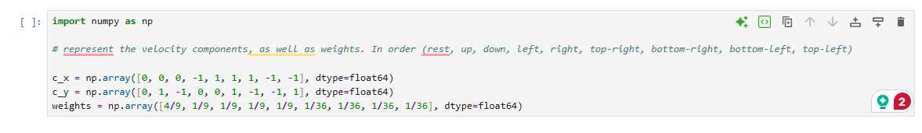
The lattice weights are mathematically calibrated to ensure the fluid behaves uniformly in all directions, counteracting the geometric bias of the square grid. Because momentum flux scales with the square of velocity, particles traveling along the longer diagonal paths exert a disproportionately high influence on the flow. Their statistical weight is deliberately reduced to 1/36 to perfectly balance this non-linear effect, ensuring the simulation accurately recovers continuous fluid dynamics.
We now need to bring in some more metrics in order to carry out our simulation. As mentioned earlier, we need to define our $f_{i}$, our statistical distribution representing fluid mass flow in the direction $i$. We will also define $ρ$, density. This follows the equation:
$$ρ= \sum_{i=0}^{8}{f_{i}}$$
We will also need to use the macroscopic velocity u, the wind speed and direction at a node. This is calculated as:
$$u= \frac{1}{ρ}\sum_{i=0}^{8}{f_{i}e_{i}}$$
We will define our grid to be of dimensions Nx, Ny where Nx is the length and Ny is the height. As $ρ$ is a scalar value, our matrix of $ρ$ values will be of dimensions (Nx, Ny). As u will need to store 2 velocities for each (y, x), we will make u a tensor of dimensions (2, Ny, Nx). And as $f_{i}$ will need to have 9 statistical components for each direction at each point, it will be defined with shape (9, Ny, Nx).
And so we can create the tensors in Python as shown:
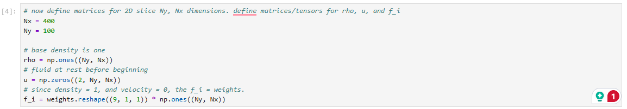
We reshape the weights matrix into a tensor with $w_{0},w_{1,⋯},w_{8}$ in layers. Then we multiply this by the ones matrix of shape (Ny, Nx). Instead of crashing, this selects the weight on each layer and multiplies it to all of the elements in the ones matrix, leaving us with 9 layers of (Ny, Nx) matrices with the nth weight broadcasted throughout the nth layer.

We will now create a Boolean mask in NumPy. This will represent if the point (x, y) we chose is one covered by the cylinder (which we will be testing in our wind tunnel).
This is done in Python as shown:
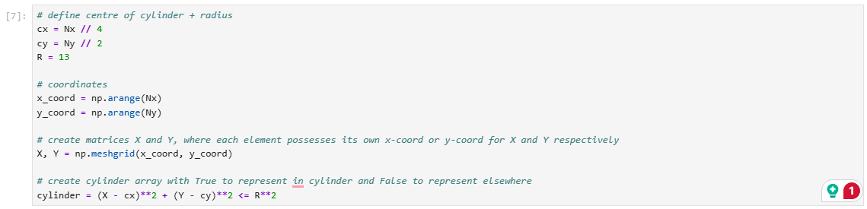
Now we can focus more on the actual mathematics of our simulation.
In a real fluid, collisions happen in a chaotic manner. Trying to calculate the result of each particle collision would be computationally impossible. So, we shall use the Bhatnagar-Gross-Krook (BGK) operator as a short-cut. This takes a macroscopic view, assuming the net effect of these trillions of collisions is simply to ‘smooth out’ the fluid. It forces the chaotic microscopic distributions to relax toward a mathematically perfect, localized state of equilibrium.
Now we want to reach this state of equilibrium, defined as $f_{i}^{eq}$. This represents what the particle distribution would be assuming perfect thermodynamic balance based on the current values of $ρ$ and u. So, we want as time goes on for the $f_{i}$ to tend towards this $f_{i}^{eq}$. The BGK operator therefore does this as follows:
$$f_{i}^{new}=f_{i}-\frac{1}{τ}\left(f_{i}-f_{i}^{eq}\right)$$
With $τ$ being the relaxation time, ie how long it takes to return to equilibrium after a disturbance. We will define $f_{i}^{eq}$ as the following:
$$f_{i}^{eq}=w_{i}ρ\left(1+3\left(c_{x,i}u_{x}+c_{y,i}u_{y}\right)+\frac{9}{2}{\left(c_{x,i}u_{x}+c_{y,i}u_{y}\right)}^{2}-\frac{3}{2}\left(u_{x}^{2}+u_{y}^{2}\right)\right)$$
Now with this noted, we may now write our code to calculate the target distribution at every time step, which comes as shown:
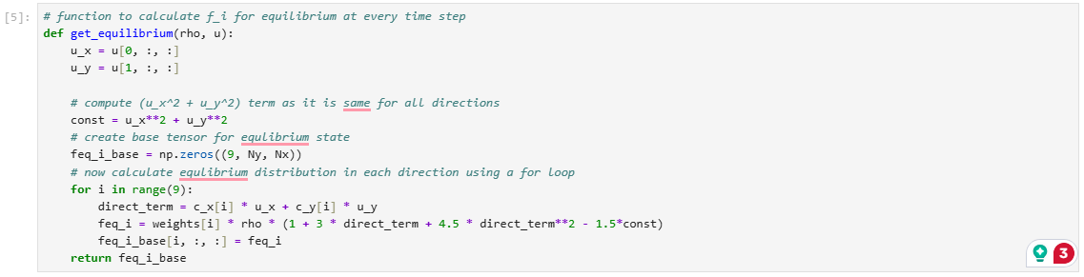
Now having written a function to compute $f_{i}^{eq}$, we can now begin to code the BGK operator. We will of course need to define a time for $τ$, the relaxation time which is positively correlated with kinematic viscosity of the liquid involved. The code for this is as shown:
Once we have implemented this, we have now accounted for the collisions of particles on a macroscopic scale. But we now need to compute the streaming, ie the movement of particles after these collisions, and the movement of their probability distribution functions with them. This requires shifting of the $f_{i}$ matrices based on the direction selected.
We will also code the simulation, so that if a particle comes into contact with cylinder, it bounces in the opposite direction of initial velocity. We will also recalculate both $ρ$ and u after each time-step so that the simulation actually works. We can use the formula for u mentioned earlier to calculate the new u after the changes in $f_{i}$ and $ρ$. The code is shown for this as follows:
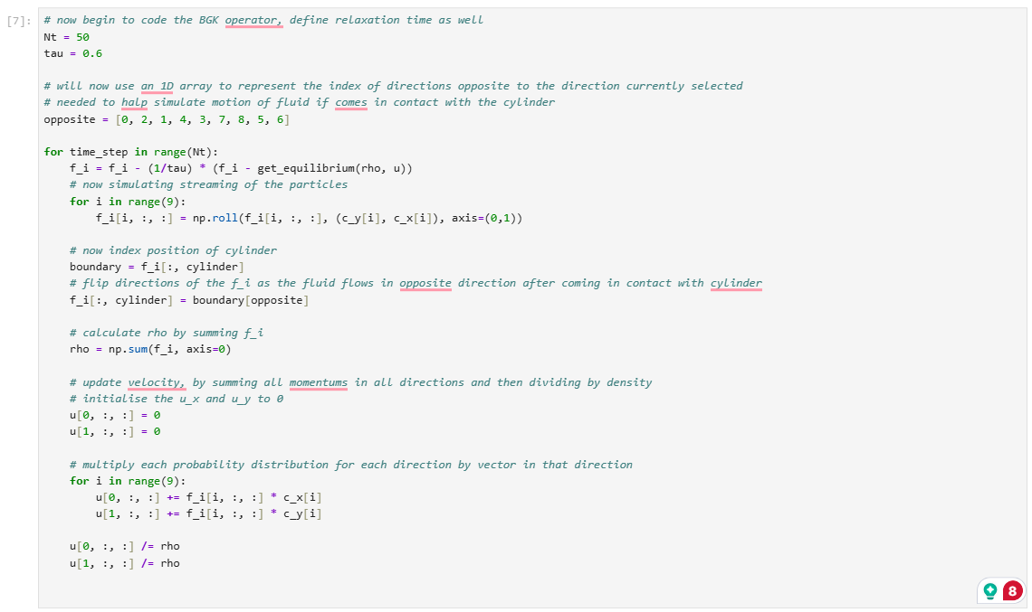
Now currently, our code works in a way which causes the wake formed at the end of the simulation to then be transferred to what’s coming into the tunnel, which is not what we want. So to ensure our fluid does not do this, we can use the ‘zero-gradient’ condition. This assumes the fluid does not change after crossing the final pixel. So we copy our second-last column of pixels and put it onto the last column of pixels.
We must also inject wind into the inlet of the tunnel. At the front of the tunnel, we will define a constant speed. For the LBM to work appropriately, we must use a low Mach number velocity.
At the end of every time-step, we will rewrite all the values in the left-hand side of the grid (at x=0) to be set with our exact horizontal velocity and a density of 1. We shall then use our get_equilibrium function to generate perfectly balanced particles for that velocity and overwrite the left wall of $f_{i}$.
The code for this is as follows:
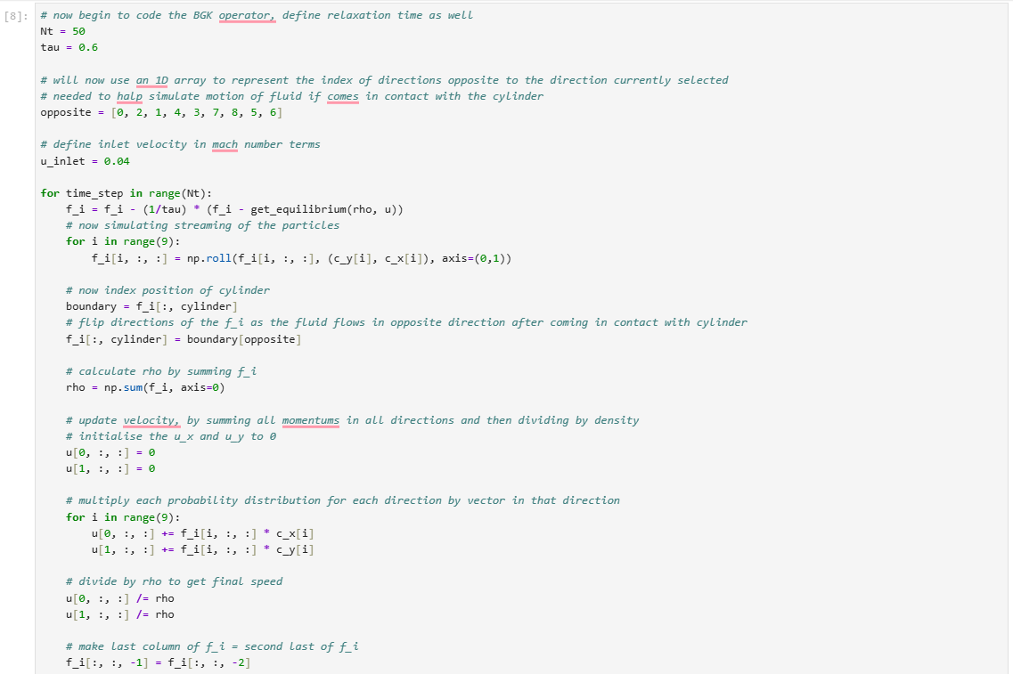
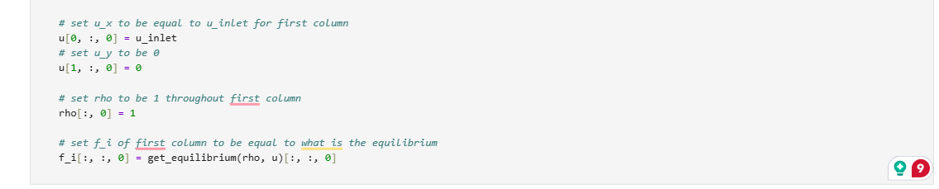
We will now use Matplotlib to generate a 2D heatmap of the flow with the scalar values of the speeds. To do this we will extract the $u_{x}$ and $u_{y}$ values using our tensor u. We will then make a 2D array of the speed at any node in the grid, using the familiar formula:
$$u=\sqrt{u_{x}^{2}+ u_{y}^{2} }$$
After writing some code, we get a nice visualisation:
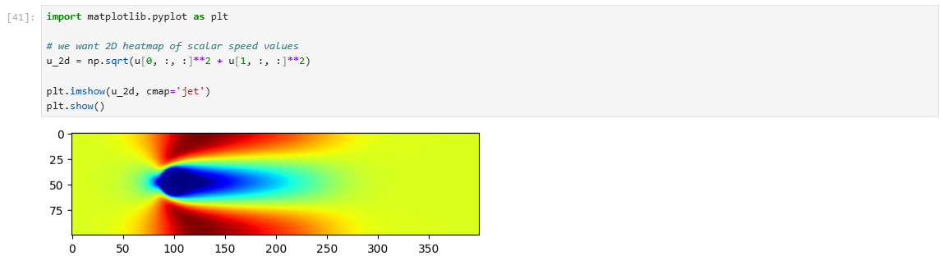

Thermal Coupling
We began this project simulating fluid flow with a stationary cylinder in the fluid’s path. We will soon replace this with a heated element to simulate a hot brake duct. We need to build the foundations for this eventual replacement by making our baseline thermal memory allocation.
We will create two new arrays, denoted by $T$ and $g_{i}$, which represent the macroscopic temperature and the microscopic temperature distribution respectively. $T$ is simply the temperature with its elements representing the temperature at those node coordinates. $g_{i}$ is a tensor representing the temperature distribution in each of our 9 directions.
Because our fluid will initially be at rest, the starting thermal distribution will be balanced. It will simply be our $w$ array multiplied by our local temperature $T$.
Just as we had a function for the equilibrium distribution for particles at a node, we also need to define an equilibrium function for the temperature distribution in our discrete directions. It is governed by the following equation:
$$g_{i}^{eq}=w_{i}T\left(1+3\left(c_{x,i}u_{x}+c_{y,i}u_{y}\right)+\frac{9}{2}{\left(c_{x,i}u_{x}+c_{y,i}u_{y}\right)}^{2}-\frac{3}{2}\left(u_{x}^{2}+u_{y}^{2}\right)\right)$$
We will again use the BGK operator for this, as shown:
$$g_{i}^{new}=g_{i}-\frac{1}{k}\left(g_{i}-g_{i}^{eq}\right)$$
Where $k$ is a quantity correlated to the thermal diffusivity, $α$.
As we are now working with heat instead of the fluid directly in this case, we do not say that heat “bounces off” our cylinder. Rather, we enforce a Dirichlet condition. We will reset the temperature of the cylinder by forcing the edge of the cylinder to have the same thermal distribution as the equilibrium distribution.
We are also, like $ρ$ earlier, able to calculate $T$ in a very similar manner, as shown:
$$T= \sum_{i=0}^{8}{g_{i}}$$
This can be implemented in code as shown:
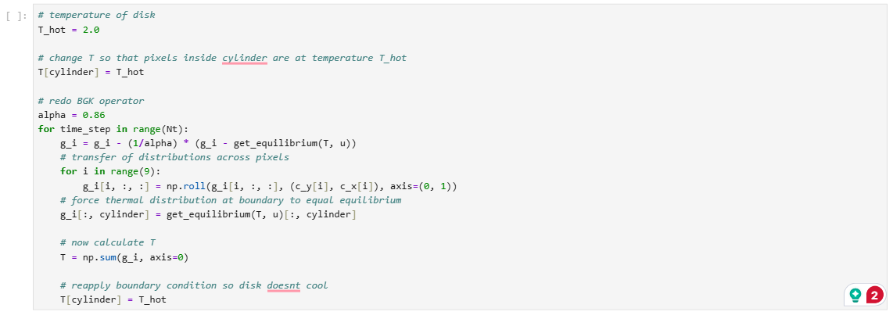
This can also be placed inside our loop for fluid simulation, which will be done. $α$ is given a value of 0.86, as the Prandtl number for air is 0.71 so this value causes this Pr to roughly be achieved. Most of the logic behind the simulation of heat flow is very similar to the logic of the particle probability distributions we coded earlier. We enforce a condition that the cylinder/disk is to be stationary.
Now we have coded an engine that continuously updates the macroscopic velocity, we now need to extract the Bernoulli pressure field and extract the convective heat transfer coefficient.
In traditional macroscopic computational fluid dynamics, extracting the pressure field is difficult, as the fluids are regarded as strictly incompressible, yielding no mathematical link between pressure and density. As a result, simulations are forced to solve Pressure-Poisson equations, which are computationally speaking quite expensive.
Our LBM bypasses this, as we have a weakly compressible, kinetic-level model. It possesses an in-built isothermal equation of state. In the topology we have employed (the D2Q9 topology), the mathematical speed of sound ($c_{s}$) is 1/sqrt(3). The pressure field is linked to the local density by the equation:
$$p= c_{s}^{2}ρ$$
Where $p$ is our pressure field, and $ρ$ our density. This gives us a trivial calculation to make for our pressure field.
We also want to extract the convective transfer coefficient in our calculations. At a macroscopic level, the cooling efficiency of our object is dictated by this equation:
$$q=h\left(T_{wall}-T_{∞}\right)$$
But, at the microscopic level, the velocity is strictly still zero, due to our non-slip condition enforced. Since there is no fluid flow directly at the surface, as the velocity is zero, the only means by which heat transfer may occur is via conduction. This means our heat flux in this scenario is exclusively defined by Fourier’s Law of Conduction:
$$q=-k∇T$$
And by conservation of energy (all heat conducted to the no-slip particles will be convected into surrounding fluid, having achieved steady state):
$$h\left(T_{wall}-T_{∞}\right)=-k∇T$$
So we can thus calculate the value of $h$.
In order to calculate our $∇T$, we will look at each of the particles surrounding the boundary. We use the following formula:
$$∇T_{local}=\frac{T_{wall}-T_{fluid}}{Δx}$$
We account for staircase effects in our discrete boundary, ie if a particle is in a diagonal direction to the particle we are considering, our $Δx=\sqrt{2}$ whereas if the nearest particle we are considering is in a cardinal direction, $Δx=1$. We set $T_{∞}=1$ making our calculation of $h$ relatively simple. The code for this is as follows:
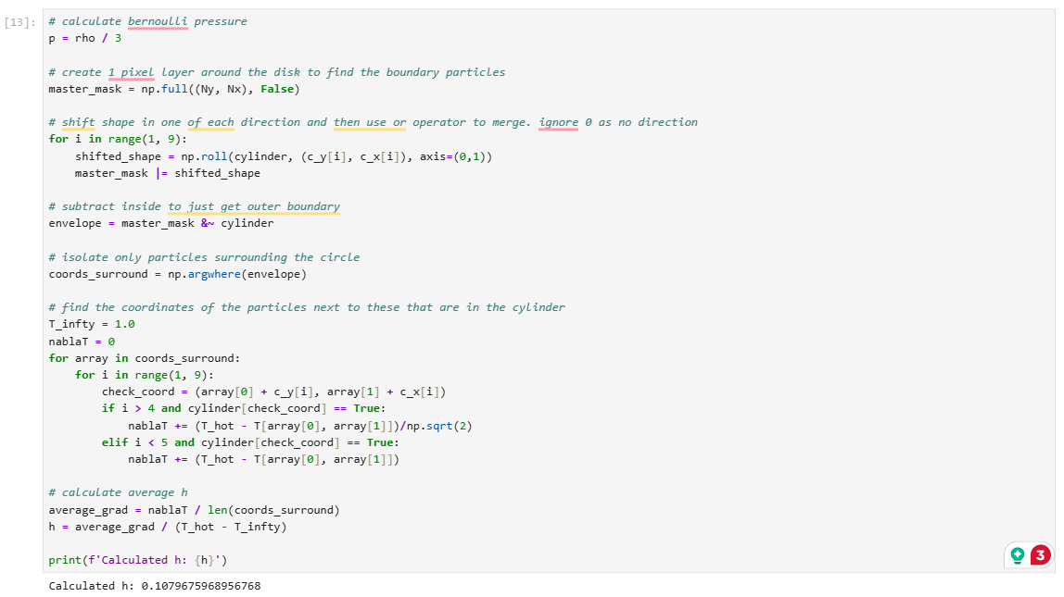
And we achieve a $h≈0.11$.

Automated Data Generation
We now have made our simulation which works for our hardcoded cylinder/disk. This works solely for our cylinder. However, in the future, we want to build a convolutional neural network (CNN) which will learn the underlying physics behind the fluid dynamics and heat transfer when given multiple examples of different shaped disks. This will allow us to, when given a new shape, instead of having to go through a 4000 time-step simulation, get some reasonable accuracy within a few milliseconds. So, we need to initially build this architecture capable of building these random shapes for us to have a dataset to train the CNN on.
To initially create our randomly shaped polygon, we can first make some evenly spaced-out angles between 0 and $2π$ for our vertices of our polygon to go on. We can then create an array of numbers picked from a uniform distribution between [5, 25) as radii from the centre for our points to be on. After that, we can use trigonometry to deduce the x and y coordinates of these points relative to the centre and shift relative to centre to get the global coordinates of these points. The code for this reads like so:
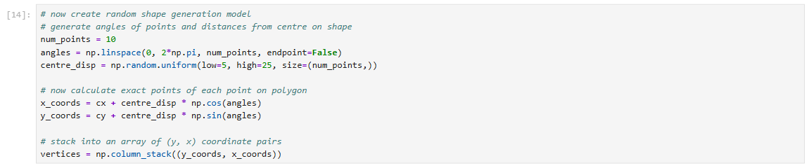
We then need to fill in the inside of the polygon and make a Boolean mask for whether a point is within our new polygon. This functions as follows:

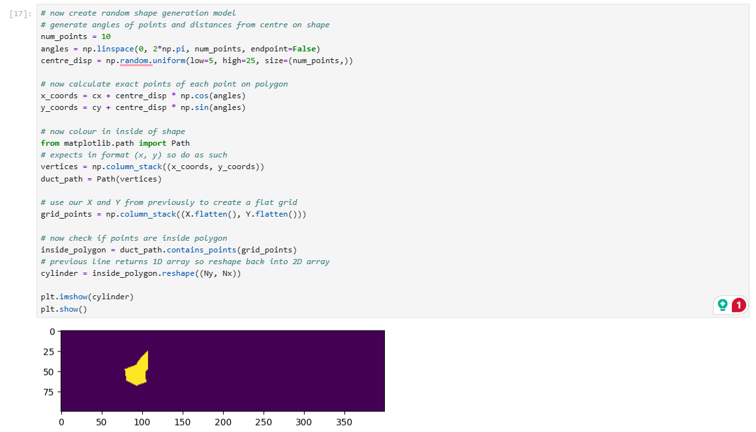
Aerodynamic drag is the force which resists the movement of an object in a fluid. This is made up of two types of drag: viscous drag, caused by the fluid travelling along the surface of the object, and the pressure drag, caused by the slamming of the fluid into the face of the object. As most of our objects will not be particularly streamlined, pressure drag will dominate. We can calculate this using the macroscopic pressure field we used earlier, where $p=\frac{ρ}{3}$. To calculate the drag, we must mathematically do the following:
$$F_{drag}=\oint_{S}{p}⋅n_{x} ds$$
Where $p$ is the pressure distribution, $n_{x}$ is the x component of the unit vector normal to the surface. Regardless of which direction we are pointing at, $n_{x} ds$ will always end up equating to 1. For a flat, orthogonal wall (e.g., looking straight right), the surface is purely vertical. The unit normal vector points strictly horizontal, so its x-component ($n_{x}$) is exactly $1$. The surface length ($ds$) is $1$.
Therefore, the effective horizontal area is $n_{x}⋅ds=1⋅1=1$.
For a diagonal wall (e.g., looking top-right at a 45-degree angle), the physics changes. The physical surface length ($ds$) is now $\sqrt{2}$. However, the unit normal vector $n$ pointing away from that surface is also angled at 45 degrees. The horizontal x-component of a 45-degree unit vector is $n_{x}=\cos\left({45}^{∘}\right)=\frac{1}{\sqrt{2}}$.
When you plug the diagonal geometry into the integral, a perfect trigonometric cancellation occurs:
$$n_{x}⋅ds=\left(\frac{1}{\sqrt{2}}\right)⋅\sqrt{2}=1$$
Which means that this will always equate to 1.
We are then able to finally complete, once we have made all our data (which amounted to around 460 cases), we are able to train our CNN. We should dive a bit deeper into how our CNN operates, before we begin to code it.
Rather than simulating fluid collision at each node, our CNN instead acts as a shortcut. It takes the geometry of our duct and maps it directly to the physical output through a series of matrix operations.
The network first receives a 100x400 matrix, a binary one representing the position of the duct at each node. Then, instead of trying to analyse all 40000 pixels, the network slides 3x3 matrices known as ‘filters’ across the grid. At each step, it calculates a dot product. The first layer lights up when it slides over a simple flat wall (a source of high pressure drag). Deeper layers combine these to recognise complex aerodynamic curves.
We use ReLU as our activation function. As fluid dynamics is inherently non-linear, if we were to rely on simple matrix multiplication, the network would collapse into a rigid linear equation. Our ReLU is a piecewise function that returns an negative number as a 0, allowing us to model complex relationships.
We also have Max Pooling. As our 100x400 grid likely contains lots of empty, useless space, this looks at 2x2 chunks of the matrix and only keeps the highest number. This results in the network discarding the empty space and only focusing on key features.
After the spatial maps are scanned and compressed three times, they are unrolled into a 1D vector of 38400 numbers. This array is then passed into a standard dense neural network (with a 512-node hidden layer), which calculates the final mathematical correlation between the visual features and the fluid dynamics.
The final layer maps the network down to exactly two nodes. We don’t apply an activation function to this step, allowing the network to output raw, physical values.
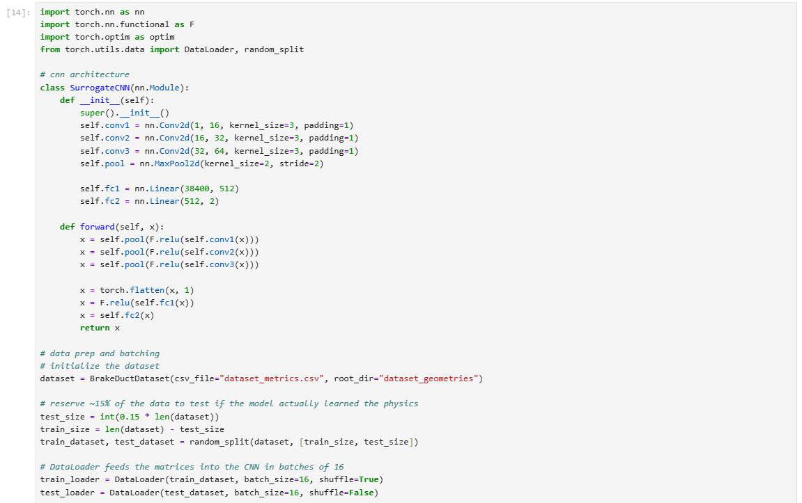
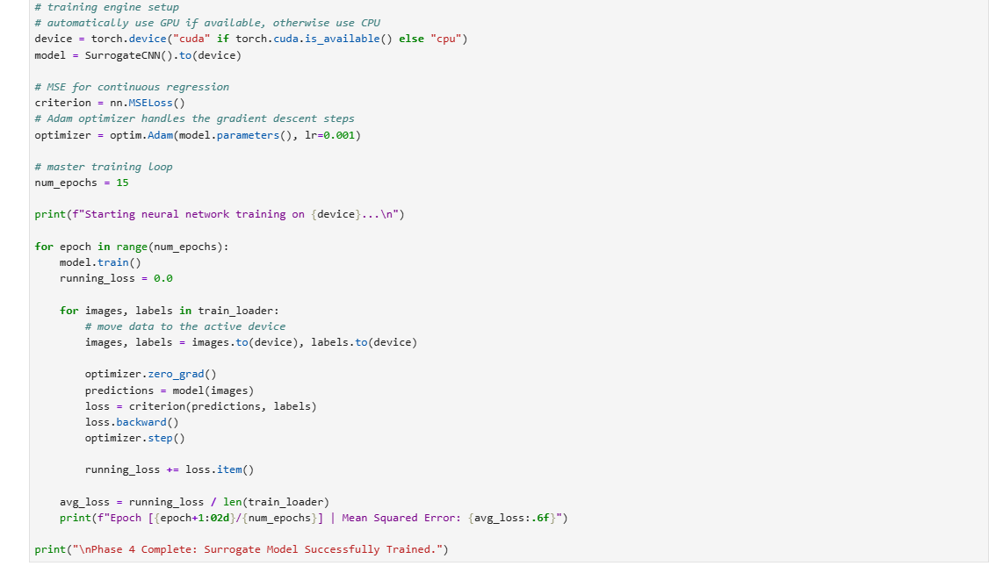
We do end up getting a decreasing MSE with each training epoch.
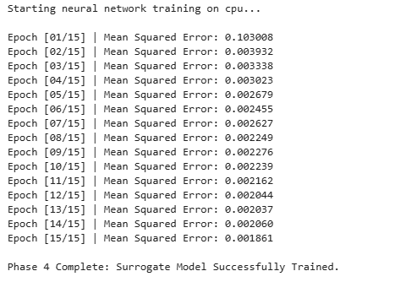
I also coded some benchmarks to see how the model did.
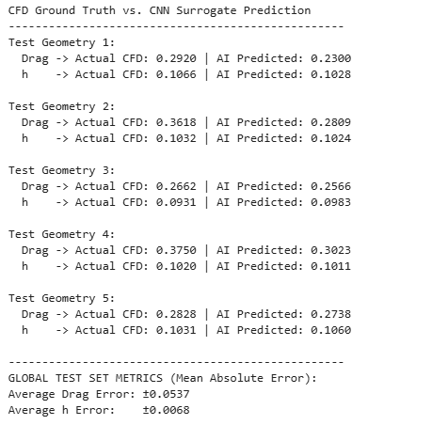
This may give the impression that the CNN learnt how the $h$ operates quite well, but the range across all examples was only really around 0.03 regardless. For drag, it was around 0.4. So in terms of learning, both quantities were learnt and predicted to roughly the same degree of accuracy. It would be fair to say that had there been more examples to train on, the model may have performed much better. It seems as though the model has perhaps slightly underfit, likely due to the lack of data. As a future improvement, the data could have been normalised, to prevent the gradients of the neural network being dominated by the larger values of drag.

